**Task 1: Write a simple program to show inheritance in scala.**

Inheritance is an object oriented concept which is used to reusability of code. You can achieve inheritance by using **extends** keyword. To achieve inheritance a class must extend to other class. A class which is extended called **super** or **parent** class. A class which extends class is called **derived** or **base** class.

Code logic:

**class** Superclass  
 {  
 **val** *value1*:String = **"Assignment 15.1 example code"** }  
 **class** baseclass **extends** Superclass{ *// base or derived class extends parent class* **val** *value2*:String = **"Scala Single Inheritance"** *println*(**"value1="**+ *value1*)  
 *println*(**"value2="**+ *value2*)  
 }  
  
 **object** Main{  
 **def** main(args: Array[String]): Unit={  
 **new** baseclass()  
 }  
  
}

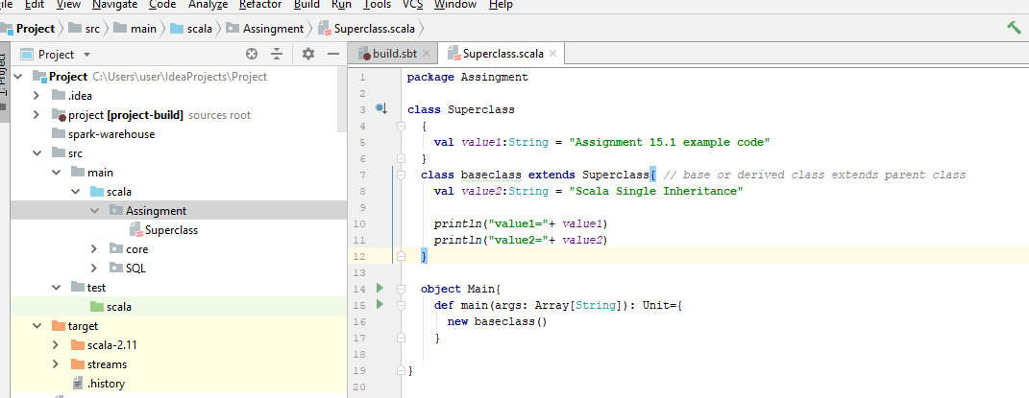

Output

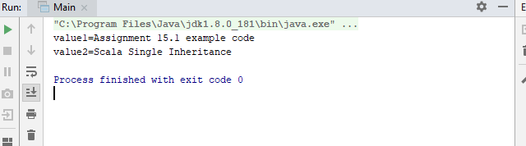

**Task 2: Write a simple program to show multiple inheritance in scala**

Multiple inheritance is a feature of some object-oriented computer programming languages in which an object or class can inherit characteristics and features from more than one parent object or parent class. It is distinct from single inheritance, where an object or class may only inherit from one particular object or class.

Scala supports various types of inheritance including single, multilevel, **multiple**, and hybrid. You can use single, multilevel and hierarchal in your class. **Multiple** and **hybrid** can only be achieved by using **traits**.

Scala **doesn’t allow for multiple inheritance** per se, but allows to extend multiple **traits**.

Traits are used to share interfaces and fields between classes. They are similar to Java 8’s interfaces.

Classes and objects can extend traits but traits cannot be instantiated and therefore have no parameters.

Traits in Scala are best described as “**interfaces that can provide concrete members**.”

**Code logic**

**trait** MultipleInheritance  
{  
 **def** show() *// defining the function show()* {  
 *println*(**"Assignment 15.1"**)  
 }  
}  
**trait** one **extends** MultipleInheritance *// extending the parent trait*{  
**override def** show()  
 {  
 *println*(**"This won't be printed"**)  
 }  
}  
**trait** two **extends** MultipleInheritance *// extending the parent trait* {  
 **override def** show()  
 {  
 *println*(**"Acadgild Scala Multiple Inheritance Example"**)  
 }  
 }  
**class** three **extends** one **with** two *//extending the base traits, calling the function show()***object** MainMulti{  
 **def** main(args:Array[String]): Unit ={  
 **var** c:three = **new** three *// it will call last function which is mentioned in the class three, changing the order will give different result* c.show()  
 }  
}

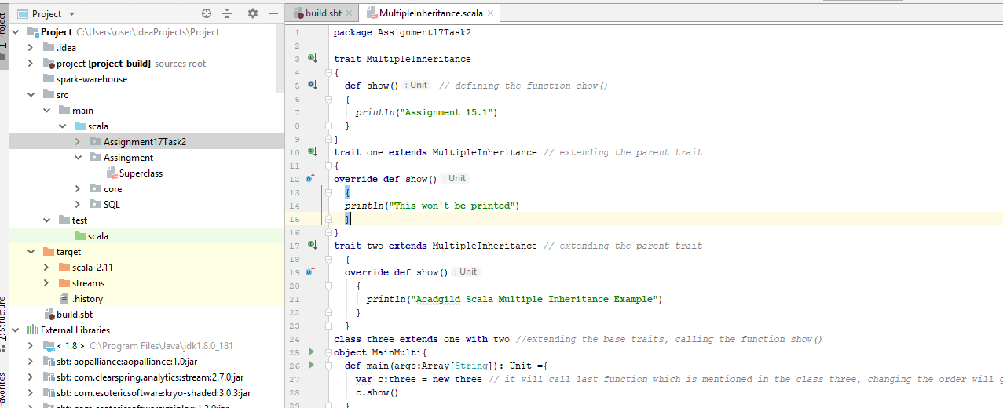

**Output result**

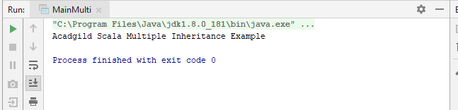

**Task 4**

**Write a program to print the prices of 4 courses of Acadgild:**

**Android App Development -14,999 INR**

**Data Science - 49,999 INR**

**Big Data Hadoop & Spark Developer – 24,999 INR**

**Blockchain Certification – 49,999 INR**

**using match and add a default condition if the user enters any other course.**

**Case 1:**

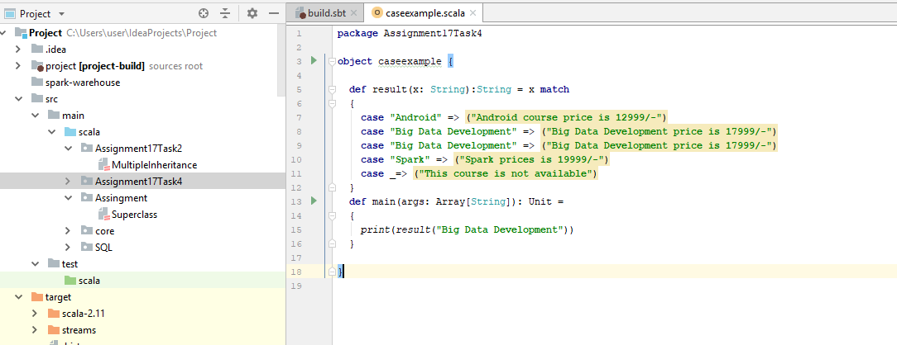

**Output**

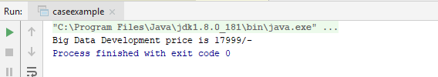

**Case 2:**

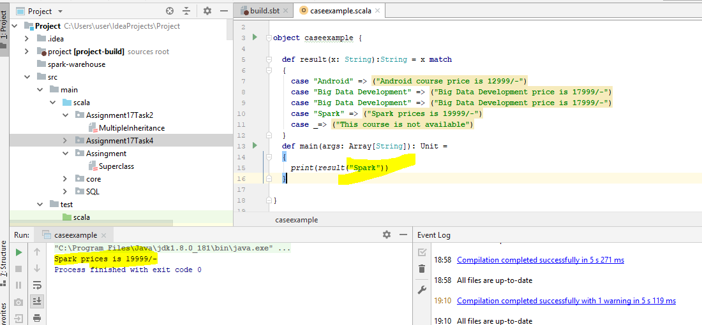

**Case 3**

